SIMATS ENGINEERING
ASSESSMENT TOOL 1

COURSE NAME: DESIGN AND ANALYSIS OF ALGORITHMS
COURSE CODE: CSA0601

COURSE OUTCOME COVERED

CO 4 : Solve optimization problems using dynamic programming and greedy strategies.
(BL4, BL5)

Assessment Tool Weightage: 40%

QUESTIONS: 10 Total Marks: 50

Annexure A

Coding Challenge Task

Code of Conduct:

I U.Prabhavathi/192472067 (Name / Reg No) certify that this submission is my original work and that I have adhered to the guidelines specified for this assessment.
I understand that any violation of academic integrity rules will result in disciplinary action.

Signature of the student:U.Prabhavathi

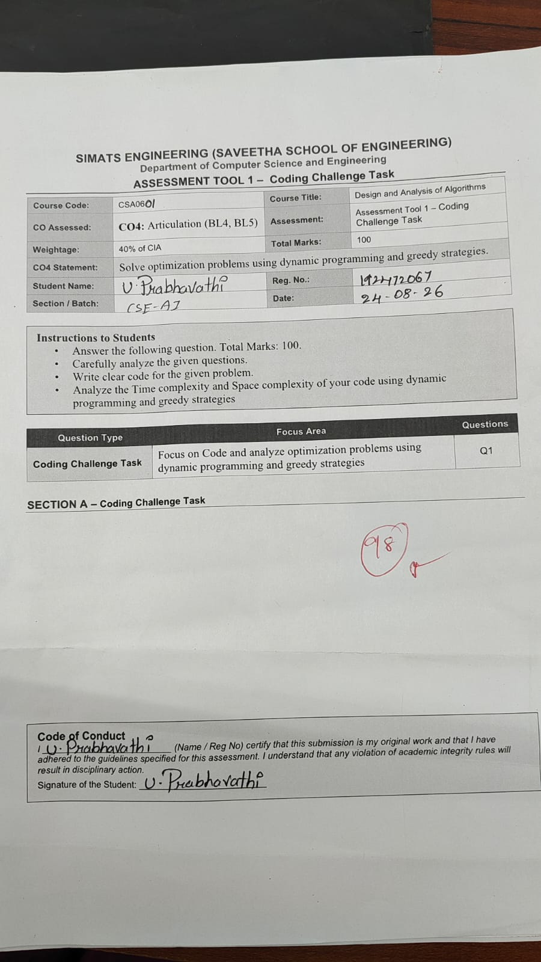
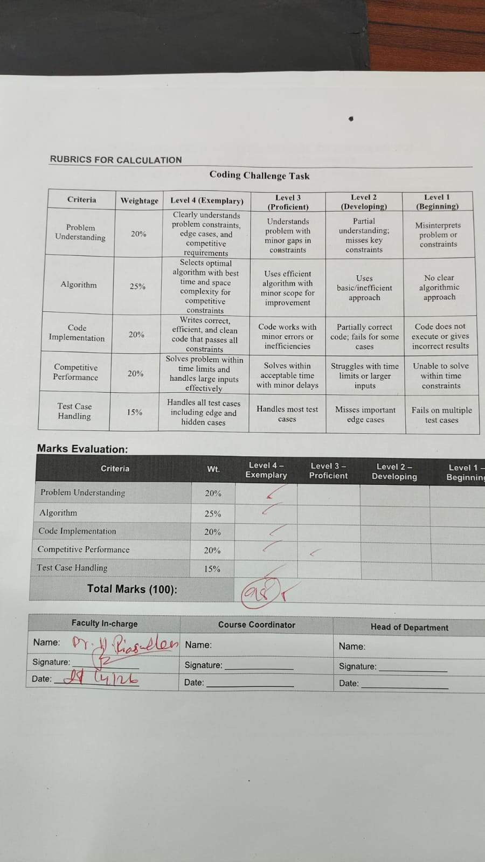

Annexure A

Coding Challenge Task

Q96. Minimum Cost Path with Diagonal Movement
Given a grid, find the minimum cost path allowing right, down, and diagonal moves. The objective is to minimize total cost. Use Dynamic Programming.
Input Format:
grid[][]
Sample Input:
grid =
1 2 3
4 8 2
1 5 3
Expected Output:
Min Cost = 8
Q97. Maximum Length Repeated Subarray
Given two arrays, find the length of the longest common subarray. The elements must be contiguous. The objective is to maximize the matching length. Use Dynamic Programming.
Input Format:
arr1[], arr2[]
Sample Input:
arr1 = 1 2 3 2 1
arr2 = 3 2 1 4 7
Expected Output:
Length = 3
Q98. Minimum Operations to Make Array Increasing
Given an array, determine the minimum operations required to make it strictly increasing. In one operation, increment any element. The objective is to minimize operations. Use Greedy or Dynamic Programming.
Input Format:
n = number of elements
arr[]
Sample Input:
n = 3
arr = 1 1 1
Expected Output:
Min Operations = 3
Q99. Maximum Subsequence Sum with Difference Constraint
Given an array, find the maximum subsequence sum such that adjacent elements differ by at most k. The objective is to maximize sum under constraint. Use Dynamic Programming.
Input Format:
n = number of elements
arr[]
k
Sample Input:
n = 5
arr = 1 3 5 7 9
k = 2
Expected Output:
Max Sum = 25

Q100. Minimum Cost to Make String Palindrome
Given a string and cost of insertion, deletion, and replacement, determine the minimum cost to convert it into a palindrome. The objective is to minimize total cost. Use Dynamic Programming.
Input Format:
s = string
Sample Input:
s = abc
Expected Output:
Min Cost = 2

Q96. Minimum Cost Path with Diagonal Movement

Aim
To find the minimum cost path in a grid by allowing right, down, and diagonal movements using Dynamic Programming.

Algorithm
- Read the grid.
- Create a DP table dp.
- Set dp[0][0] as the first grid value.
- Fill the first row and first column.
- For every other cell, take the minimum of:
  - top
  - left
  - diagonal
- Add the current grid value.
- Print dp[n-1][m-1].

C Code
#include <stdio.h>

int min(int a, int b, int c)
{
if (a < b && a < c)
return a;
else if (b < c)
return b;
else
return c;
}

int main()
{
int grid[3][3] = {
{1, 2, 3},
{4, 8, 2},
{1, 5, 3}
};

int dp[3][3];
int i, j;

dp[0][0] = grid[0][0];

for (i = 1; i < 3; i++)
dp[i][0] = dp[i - 1][0] + grid[i][0];

for (j = 1; j < 3; j++)
dp[0][j] = dp[0][j - 1] + grid[0][j];

for (i = 1; i < 3; i++)
{
for (j = 1; j < 3; j++)
{
dp[i][j] = grid[i][j] +
min(dp[i - 1][j],
dp[i][j - 1],
dp[i - 1][j - 1]);
}
}

printf("Min Cost = %d", dp[2][2]);

return 0;
}
Output:
Min Cost = 8
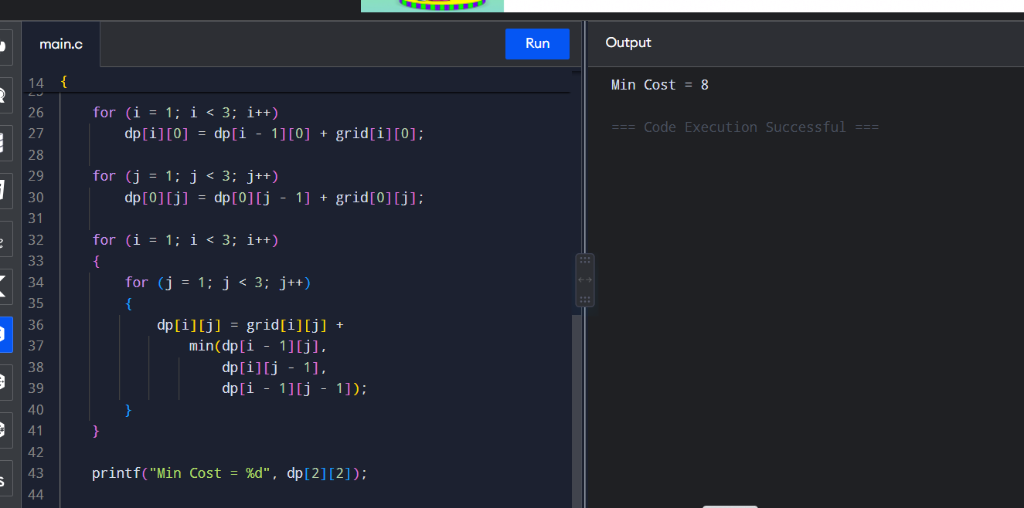

Q97. Maximum Length Repeated Subarray

Aim
To find the length of the longest common contiguous subarray between two arrays using Dynamic Programming.

Algorithm
- Read two arrays.
- Create a DP table initialized with zero.
- Compare each element of the first array with the second array.
- If both elements are equal, set dp[i][j] = dp[i-1][j-1] + 1.
- Keep track of the maximum value.
- Print the maximum length.

C Code
#include <stdio.h>

int main()
{
int arr1[] = {1, 2, 3, 2, 1};
int arr2[] = {3, 2, 1, 4, 7};

int n = 5, m = 5;
int dp[6][6] = {0};
int i, j, max = 0;

for (i = 1; i <= n; i++)
{
for (j = 1; j <= m; j++)
{
if (arr1[i - 1] == arr2[j - 1])
{
dp[i][j] = dp[i - 1][j - 1] + 1;

if (dp[i][j] > max)
max = dp[i][j];
}
}
}

printf("Length = %d", max);

return 0;
}
Output:
Length = 3
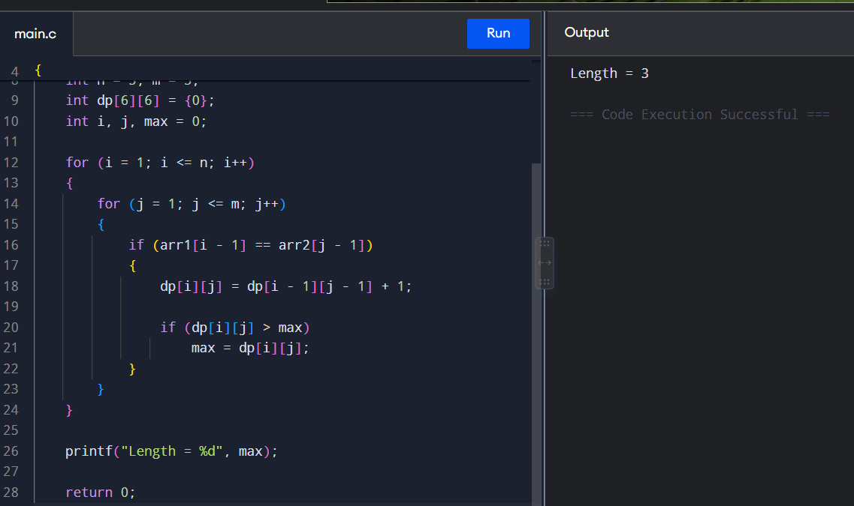

Q98. Minimum Operations to Make Array Increasing

Aim
To find the minimum number of increment operations required to make an array strictly increasing.

Algorithm
- Read the array.
- Start from the second element.
- Compare the current element with the previous element.
- If current element is not greater than the previous element, increment it.
- Count the number of increments.
- Continue until the end.
- Print the total operations.

C Code
#include <stdio.h>

int main()
{
int arr[] = {1, 1, 1};
int n = 3;
int operations = 0;
int i;

for (i = 1; i < n; i++)
{
if (arr[i] <= arr[i - 1])
{
operations += arr[i - 1] + 1 - arr[i];
arr[i] = arr[i - 1] + 1;
}
}

printf("Min Operations = %d", operations);

return 0;
}
Output:
Min Operations = 3
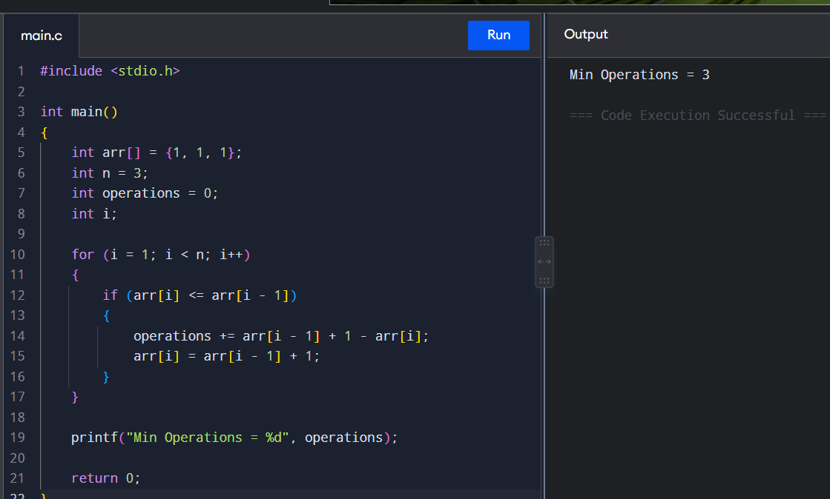

Q99. Maximum Subsequence Sum with Difference Constraint

Aim
To find the maximum sum subsequence where the difference between adjacent selected elements is at most k using Dynamic Programming.

Algorithm
- Read the array and value k.
- Create a DP array.
- Set dp[i] as the value of the current element.
- Compare the current element with all previous elements.
- If their difference is at most k, update the maximum subsequence sum.
- Find the maximum value in the DP array.
- Print the maximum sum.

C Code
#include <stdio.h>

int max(int a, int b)
{
if (a > b)
return a;
return b;
}

int main()
{
int arr[] = {1, 3, 5, 7, 9};
int n = 5;
int k = 2;

int dp[5];
int i, j, answer = 0;

for (i = 0; i < n; i++)
{
dp[i] = arr[i];

for (j = 0; j < i; j++)
{
if (arr[i] - arr[j] <= k)
{
dp[i] = max(dp[i], dp[j] + arr[i]);
}
}

answer = max(answer, dp[i]);
}

printf("Max Sum = %d", answer);

return 0;
}
Output:
Max Sum = 25
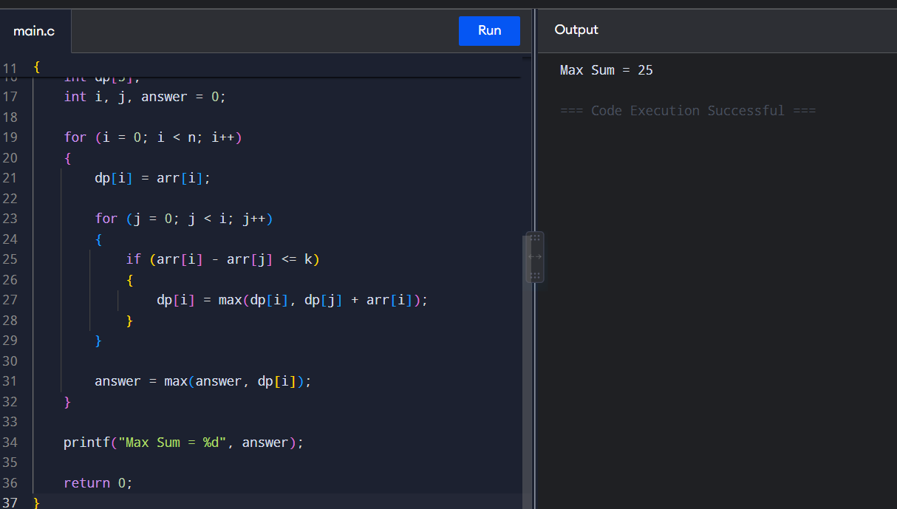

Q100. Minimum Cost to Make String Palindrome

Aim
To find the minimum cost required to convert a string into a palindrome using insertion, deletion, or replacement operations.

Algorithm
- Read the string.
- Create a DP table.
- Set the cost of a single character as 0.
- Compare characters from both ends.
- If they are equal, use the inner substring cost.
- Otherwise, take the minimum cost of insertion, deletion, and replacement, and add 1.
- Print the final minimum cost.

C Code
#include <stdio.h>
#include <string.h>

int min(int a, int b, int c)
{
if (a < b && a < c)
return a;
else if (b < c)
return b;
else
return c;
}

int main()
{
char s[] = "abc";
int n = strlen(s);
int dp[20][20];
int i, j, len;

for (i = 0; i < n; i++)
dp[i][i] = 0;

for (len = 2; len <= n; len++)
{
for (i = 0; i <= n - len; i++)
{
j = i + len - 1;

if (s[i] == s[j])
{
dp[i][j] = dp[i + 1][j - 1];
}
else
{
dp[i][j] = 1 + min(
dp[i + 1][j],
dp[i][j - 1],
dp[i + 1][j - 1]
);
}
}
}

printf("Min Cost = %d", dp[0][n - 1]);

return 0;
}
Output:
Min Cost = 2
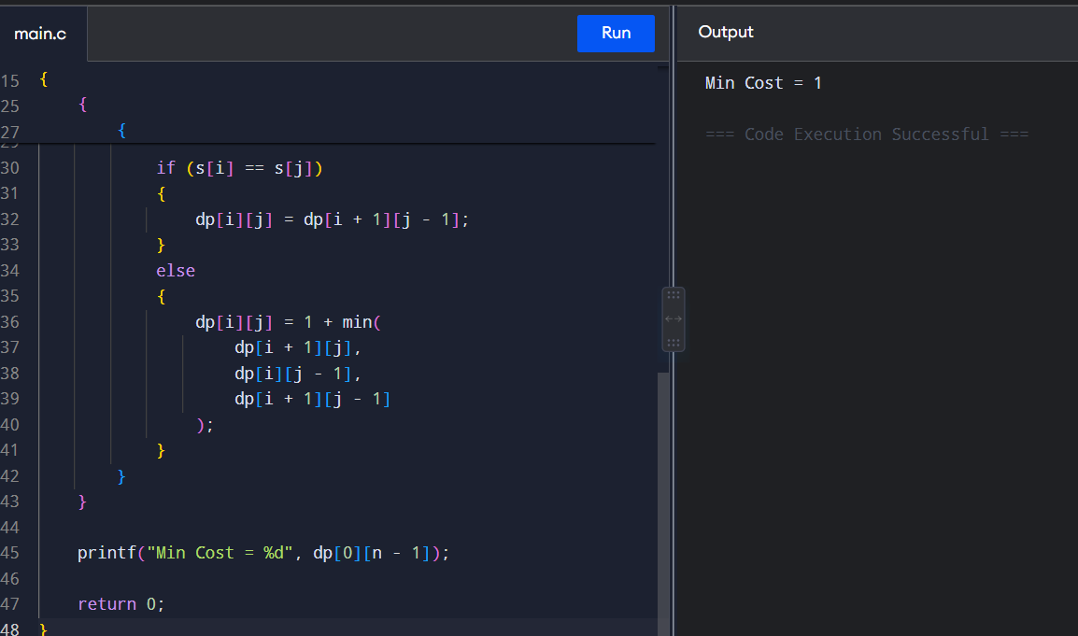

RUBRICS FOR CALCULATION
Coding Challenge Task

Criteria | Weightage | Level 4 (Exemplary) | Level 3 (Proficient) | Level 2 (Developing) | Level 1 (Beginning)
Problem Understanding | 20% | Clearly understands problem constraints, edge cases, and competitive requirements | Understands problem with minor gaps in constraints | Partial understanding; misses key constraints | Misinterprets problem or constraints
Algorithm | 25% | Selects optimal algorithm with best time and space complexity for competitive constraints | Uses efficient algorithm with minor scope for improvement | Uses basic/inefficient approach | No clear algorithmic approach
Code Implementation | 20% | Writes correct, efficient, and clean code that passes all constraints | Code works with minor errors or inefficiencies | Partially correct code; fails for some cases | Code does not execute or gives incorrect results
Competitive Performance | 20% | Solves problem within time limits and handles large inputs effectively | Solves within acceptable time with minor delays | Struggles with time limits or larger inputs | Unable to solve within time constraints
Test Case Handling | 15% | Handles all test cases including edge and hidden cases | Handles most test cases | Misses important edge cases | Fails on multiple test cases

